SYLLABUS FOR PERIODIC ASSESSMENT-I EXAMINATION (SESSION 2026-27)

SUBJECT | ENGLISH | HINDI | MATHEMATICS | SCIENCE | SOCIAL SCIENCE |  | SANSKRIT
Class VII | READING COMPREHENSION  Unseen passage  LITERATURE : POORVI  UNIT 1  CH 1- The Day The River Spoke  CH 2- (Poem)- Try Again  WRITING SECTION  Notice Writing  GRAMMAR SECTION  Preposition | 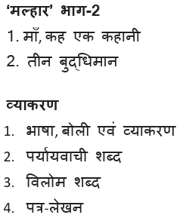 | Ganit Prakash Part –I  Chapter 1 Large numbers around us  Chapter 2 – Arithmetic Expressions |  | - Story of Indian Agriculture  - India and Her neighbour |  | - वन्दे भारतमातरम  शब्द रूपाणि
  BOOK: CURIOSITY GRADE 7
  CHAPTER 2:
  Exploring substance : Acidic,
  Basic and Neutral
  CHAPTER 3:
  Electricity: Circuits and their
  Components
Class VIII | Reading Section : Unseen passages Writing Section : Notice Writing and Informal Letters  Grammar Section: Use of Punctuation and Capital Letters  Literature Section:  PoorvI – Class VIII  Poem- The Concrete Example  Ch1- The Wits that Won the Hearts  Ch2- Part-I  The Road to Ujjain  Ch2- Part-II  The King’s Court | 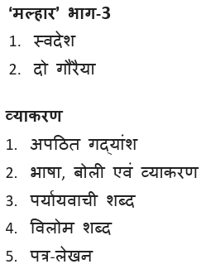 | Ganit Prakash Part –I  Chapter 1 : A Square and A cube  Ganit Prakash Part –II  Chapter 1 : Fractions in disguise | Chapter 1 Exploring the Investigative World of Science  Chapter 2 The Invisible Living World : Beyond Our  Naked Eye  Chapter 3 Health : The Ultimate Treasure |  | - Natural resources and their uses  - Reshaping of India’s political map | संगच्छध्वं संवदध्वम्  अल्पानामपि वस्तूनां संहति :  कार्यसाधका

SYLLABUS FOR PRE MID TERM EXAMINATION (SESSION 2026-27)

SUBJECT | ENGLISH | HINDI | MATHEMATICS | SCIENCE | SOCIAL SCIENCE
Class IX | Reading Section : Unseen passages  Writing Section : Informal invitation ,notice writing  Grammar Section: Tense , modals  Literature Section: Kaveri  Ch 1 : How I taught my grandmother to read?  Ch 2 : The pot maker  Poem : Bharat our Land | 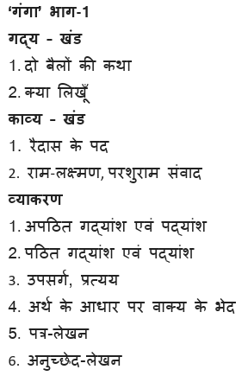 | GANIT PRAKASH PART 1  Chapter 1 : Number System  Chapter 2 : Polynomials | - The fundamental unit of Life  - Motion  - Mixtures and Separation techniques | - Understanding Social Science  - Beginning of Civilisation  - Landforms : Earth’s living canvas  - Why Choices matter: the basics of Economics
Class X | Reading Section : Unseen passages  Writing Section : Letters Enquiry and to Editor  Grammar Section: Determiners  Literature Section:  First Flight :  Poem: 1 Dust of Snow 2 Fire and Ice  Footprints Without Feet  Lesson-1 A Triumph of Surgery .  Lesson-2 The Thief’s Story  Lesson3- The Midnight Visitor | 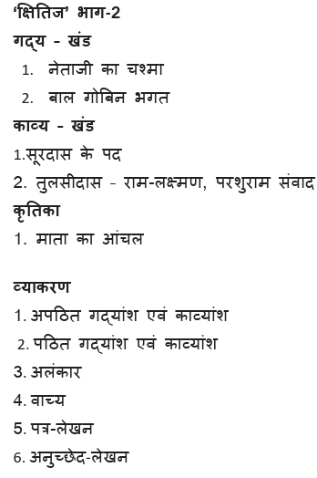 | Chapter 1 Real Numbers  Chapter 2 Polynomials  Chapter 3 Pair of linear equations in two variables  Chapter 4 Quadratic equations | BIOLOGY  - Life Processes  PHYSICS  - Light- Reflection and Refraction  CHEMISTRY  - Chemical reactions and equations | History  Rise of nationalism in Europe  Pol. Science  Power Sharing  Geography  Resource and development  Economics  Development

SYLLABUS FOR PERIODIC TEST –I EXAMINATION (SESSION 2026-27)

SUBJECT | ENGLISH | MATHEMATICS | PHYSICS | CHEMISTRY | BIOLOGY | COMP. SCIENCE
Class XI | Reading Skills: Unseen passages, Note Making,  Summary  Grammar and Creative Writing Skills: Tenses,  Poster and Advertisement  Literature: Hornbill- The Portrait of a Lady,  (Prose), A Photograph (Poem)  Snapshots-The Summer of the Beautiful White  Horse and The Address | Ch no.1 Sets  Ch no.2 Relations and functions  Ch no.3 Trigonometric functions | Chapter – 2 Units and measurements  Chapter – 3 Motion in a Straight line  Chapter – 4 Motion in a Plane | Ch 1: Some Basic concepts of chemistry  Ch 2: Structure of Atom | Ch -08 : Cell : the unit of Life  Ch -09 : Biomolecules  Ch -10 : Cell Cycle and Cell Division | Unit I: Computer Systems and Organisation  ● Basic Computer Organisation  ● Types of software  ● Operating system (OS)  ● Boolean logic  ● Number system  ● Encoding schemes
Class XII | Reading Skills: Unseen passages  Grammar and Creative Writing Skills: Notice  Writing, Formal and Informal Invitation  Literature: Flamingo: The Last Lesson, Lost Spring  (Prose), My Mother at Sixty-Six (Poem)  Vistas :The Third Level | Ch no. 1 Relations and Functions  Ch no. 2 Inverse Trigonometric Functions  Ch no. 3 Matrices  Ch no. 4 Determinants and Application of Matrices  Ch no. 5 Continuity and Differentiability | CH-1- Electric charges and  Fields  CH-2- Electrostatic potential  And capacitance | Unit – I, Solutions  Unit – II, Electrochemistry  Unit-III d and f block elements | Ch 01 : Sexual reproduction in flowering Plants  Ch 02 : Human Reproduction  Ch 03 : Reproductive Health | - Revision of Python topics covered in Class XI  - Functions:

