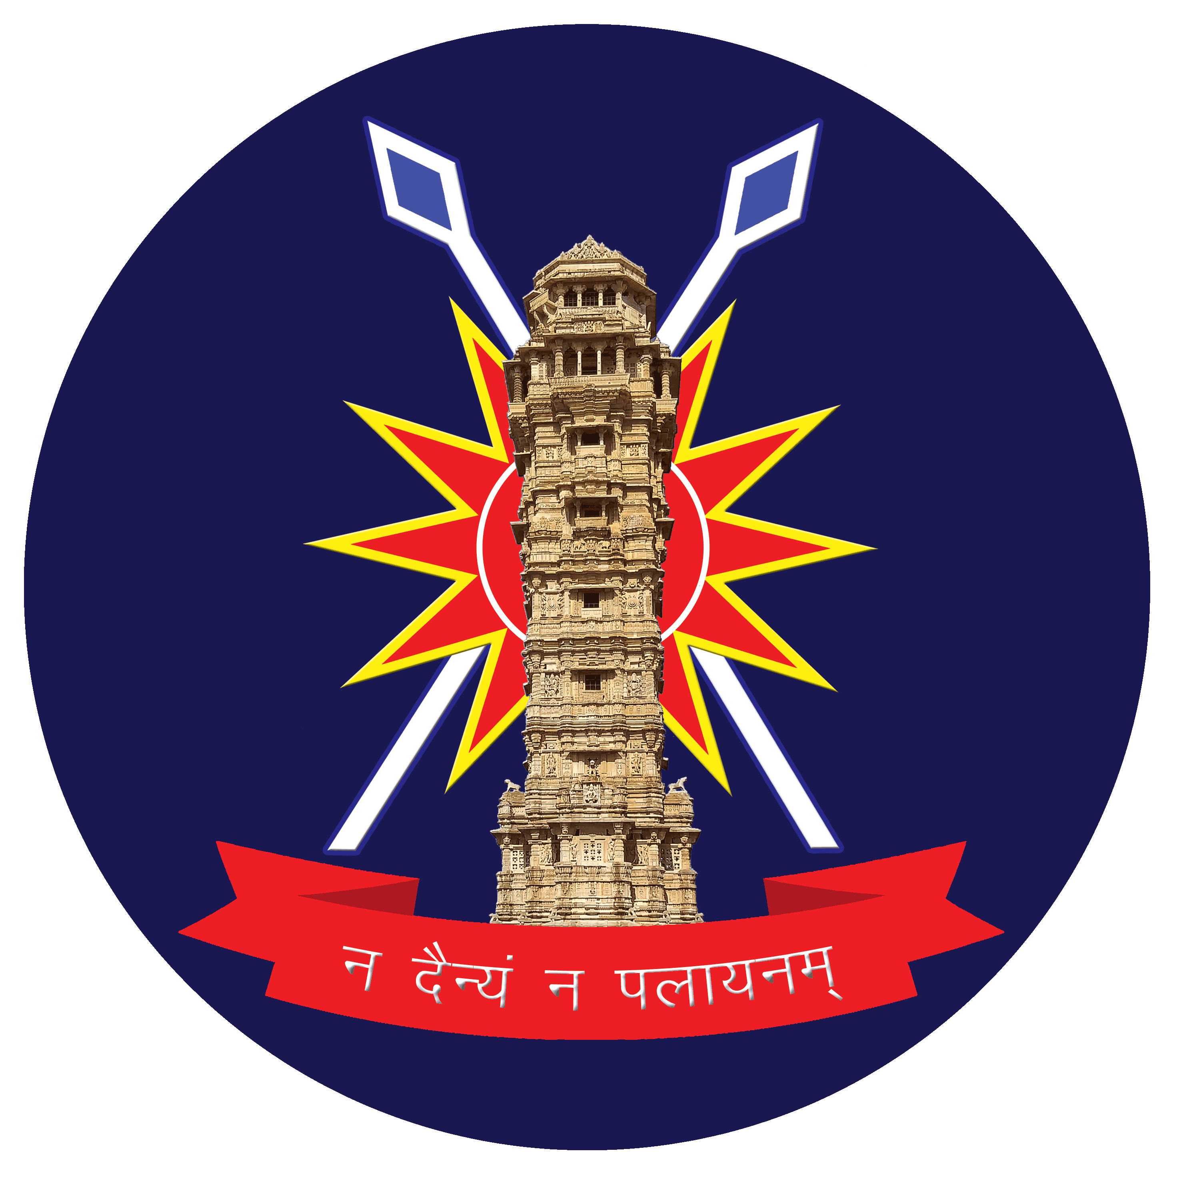
Sainik School Chittorgarh Bhilwara Road
Chittorgarh
Rajasthan 312021

INTERNAL EXAMINATIONS
HALF YEARLY / MID TERM EXAMINATION/ PERIODIC TEST-II
ACADEMIC YEAR 2026-27

- The following examinations for the AY 2026-27 will be conducted from 09 Oct 2026 to 21 Oct 2026 :-

SER | CLASS | EXAMINATION | Syllabus to be covered
(a) | VI- VIII | Half yearly | 50%
(b) | IX | Mid - Term Examination | 50%
(c) | X | Mid - Term Examination | 70%
(d) | XI | Periodic Test-II | 50%
(e) | XII | Periodic Test-II | 50%
2. The Schedule of aforementioned Examination is as follows:-

CLASS$→$ | VI |  | VII | VIII |  |  | IX |  |  |  | X | XI |  |  |  | XII
DATE/DAY
09 Oct 2026,  Friday | Science |  | Maths | Science |  |  | Maths |  |  |  | Social  Science | Physics |  |  |  | Maths
10 Oct 2026 | Comp |  | Comp | Comp |  |  | Comp |  |  |  | Comp | -- |  |  |  | --
11 Oct 2026 | SUNDAY
12 Oct 2026,  Monday | Sanskrit | Hindi |  | Sanskrit |  |  |  | English |  |  | Hindi |  | Maths |  | Chemistry
13 Oct 2026,  Tuesday | No Examination
14 Oct 2026,  Wednesday | Maths | Sanskrit |  |  | Hindi |  |  | Science |  | English |  |  | Bio/CS | English
15 Oct 2026,  Thursday | No Examination
16 Oct 2026,  Friday | Social  Science |  | English |  |  | English |  |  | Hindi | Maths |  |  | English | Bio/CS
17 Oct 2026,  Saturday | No Examination
18 Oct 2026 | SUNDAY
19 Oct 2026,  Monday | English |  | Science |  | Maths |  |  | Social  Science |  | Science |  |  | Chemistry |  |  | Physics
20 Oct 2026,  Tuesday | DUSSEHRA
21 Oct 2026,  Wednesday | Hindi |  | Social  Science |  | Social  Science
3. The Timings for the Examination will be as follows:

(a) For Class VI to VIII : 1000h -1230h
(b) For Class IX to XII : 1000h- 1300h

